Resumo – Unix, Bash & Shell Script

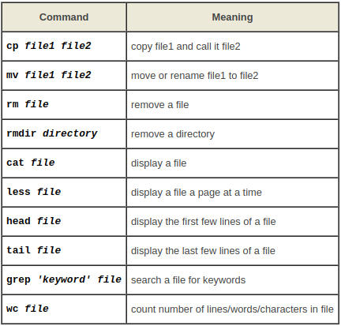

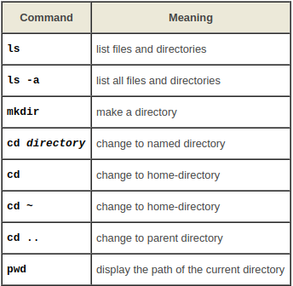

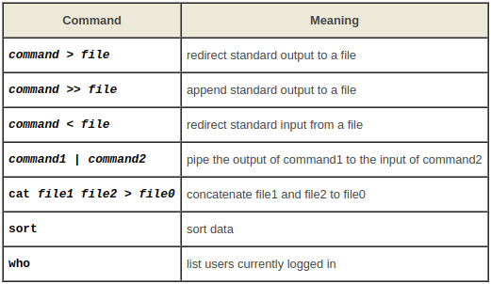

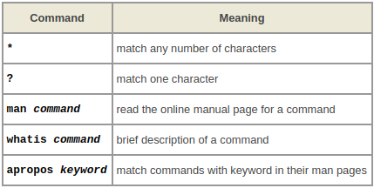

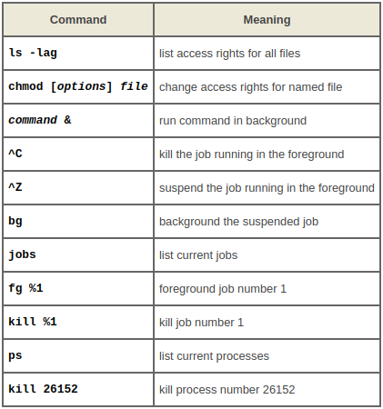
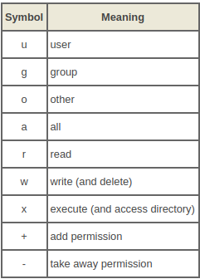

comandos: ls, mkdir, cd, pwd, cp, mv, rm, rmdir, clear, cat, less, head, tail, grep, wc, >, >>, |, sort, who, man, whatis, apropos, *, ?, chmod, ps, bg, kill, find, history, echo.

Referências:

https://aurelio.net/shell/canivete/

